Ideal for decorative siding and interiors
PREPAINTED
NEW PRIME
ALBAYALDE WHITE

- Wide range of uses, easy to paint, dye or varnish.
- Faster construction and finish.
- Ideal for fixing furniture and shelves to walls.

COLONIAL OSB
INTERIOR DECORATION
- Sanded and grooved R2/RV4 panel
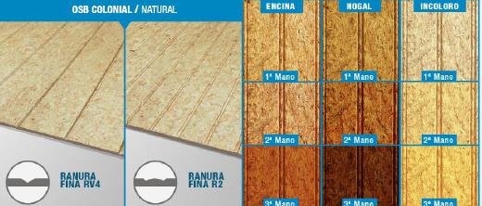

COLONIAL OSB / NATURAL

FINE GROOVE RV4 / R2
HOLM OAK / WALNUT / COLORLESS
FIRST, SECOND, THIRD LAYER

PRODUCT

LP OSB Colonial panels are made in Chile with the highest technology by Louisiana Pacific, world leader in OSN structural panel manufacturing.

LP has created a decorative product for interior home use as wall and ceiling siding.

OSB Colonial is an OSB panel that has been sanded on one of its sides and which also has a colonial grove every 2” and RV4. It also has a notch for a better union between panels.

CHARACTERISTICS
Uses

- Walls internal siding
- Ceiling internal siding

Format
- LP OSB Colonial R2 – 9,0mm 1.22 x 2.44 / 90 u. x pallet
- LP OSB Colonial RV4 – 9,0mm 1.22 x 2.44 / 90 u. x pallet

Benefits

- Faster construction and finish.
- Easy to install, with built-in joints solution
- LP products do not cause Silicosis when working with or being exposed to them, as they do not contain silicon dioxide.
- It does not require special tools.
- It allows home industrialization.
- It can be dyed or varnished.

STORAGE

Panels should be stored in clean and dry areas, off the ground and under a roof. They should be on a flat surface and at least with 4 supporting shafts.

Take all necessary precautions to prevent panels from splinting or damage on their edges during transportation. In addition, avoid dropping the panels.

STABILIZATION
Stabilization is defined as the process through which the moisture content of panel equals the wood’s moisture of equilibrium in the area where the siding will be used.

The moisturizing process should be done if the panel’s moisture is below the atmospheric moisture of the installation zone. The process consists of soaking the panels with 1 to 3 lt. of water ensuring an equal distribution and then let them dry from 2 to 4 days, until reaching the moisture of equilibrium. The drying process should be done if the panels’ moisture is greater than that of the moisture of equilibrium of the installation zone.
A change in moisture content translates into the panels’ and wood dimensional variation. For this reason, it is important for the panel to reach the equilibrium moisture prior to installation so that there are future deformations in structures and panels.

According to Chilean Regulation 1198 “Wood and its derived elements must have, at the time of use, a moisture content equal to that of equilibrium moisture of its service location.”

INSTALLATION
Prior considerations

It is an interior siding, with vertical grooves and overlaps for joints.

LP OSB Colonial panels can be installed directly on a self-supported structure, be it made of wood or metal.

It is of great importance that the surface to cover is straight and aligned, as the siding will copy surface imperfections.

Fastening

The panels should be installed with 6x11/4” CRS zinc screws or 2” helical nails.
As the picture shows, fasten 1cm away from the edge, every 15 cm in the perimeter and every 30 cm in the interior supports.

To reduce panel fastenings, use wood structural adhesives (Titebond’s Drywall, Dynal, Sika, etc.). In combination with adhesive you can use nails, tips, or screws every 30 cm on the edges and every 50 cm in the center.

FINISHES

Use only water-based varnishes and paints (100% water-based latex or water-based paint). For a better finish cover screws with wood putty.
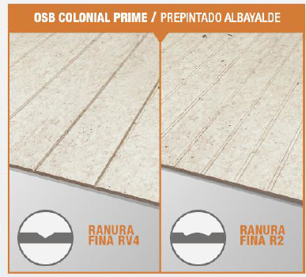
OSB COLONIAL PRIME / PREPAINTED ALBAYALDE
FINE GROOVE RV4 / FINE GROOVE R2
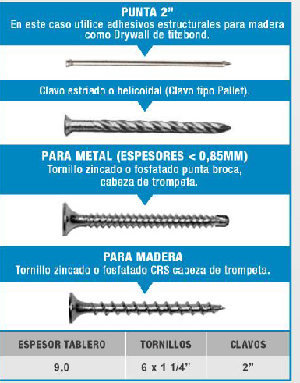
2” TIP In this case use wood structural adhesive as Titebond’s Drywall
Helical nail (Pallet type)
FOR METAL (THICKNESS < 0,85MM)
Zinc or phosphate drill tip screw
FOR WOOD
Zinc or phosphate CRS screw
PANEL THICKNESS – SCREWS - NAILS

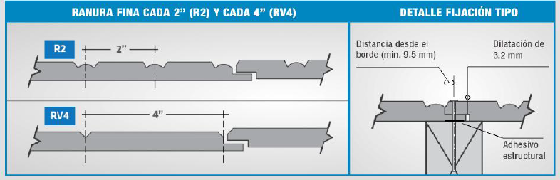

FINE GROOVE EVERY 2” (R2) AND EVERY 4” (RV4)
STANDARD FASTENING DETAIL
Distance from the border (min. 9.5 mm), 3.2mm expansion, structural adhesive

